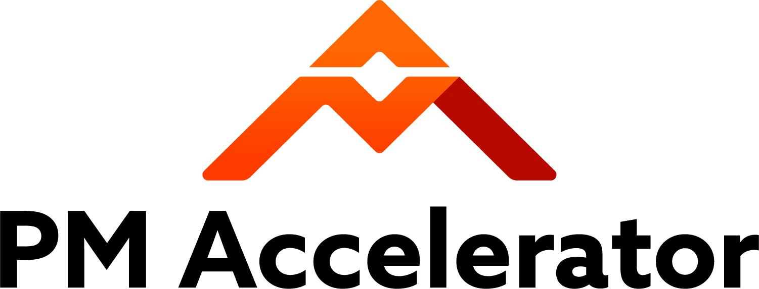

Bootcamp Journey
Use this document as a high-level overview of your journey.
This document will reference both these aspects:
- Technical Skills Development
  - Core ML/AI Concepts
  - Gen AI & Data Engineering
  - MLOps & Deployment
- Project-Based Learning
  - Agile Scrum Methodology
  - Team Collaborations
  - Real-world Applications

Project Timeline
Here is a high-level timeline of your 11-week journey.
Week 1 - 11 Agenda for AI PM Bootcamp
- Week 1: Learning and Onboarding Study all the AI knowledge:
  - Training for AI Engineers
  - Engineers’ Training Youtube Playlist
  - Training of AI Designers
  - Designers’ Training Playlist
  - Engineers: Working on Job Assistant Agent or Discord RAG FAQ Chatbot
    - Make sure to join Office hours to discuss your thoughts and issues with these projects. (every Saturday)
- Week 2: Learning and Onboarding Study all the AI knowledge:
  - Engineers/Data Scientists
    - Training for AI Engineers
    - Engineers’ Training Youtube Playlist
  - Designers
    - Training of AI Designers
    - Designers’ Training Playlist
  - Designers: Join Pitch Day & Team Match (within 24 fill out AI products interested in on Team Match.xls for Cohort 7) -
    - Designers and PM’s need to reach out to each other and determine if they are a good match. Each team can initially have 2 designers. (1 - Senior + 1 - Junior)
      - Format: Full_Name(Role - Senior/Junior)
        - Senior 2 or more years of experience
    - After designers join the team: Discuss User Interview process [PM to lead this discussion] ⇒Prioritize Fast matching this week
    - Main communication = Discord (check daily)
  - Engineers: Working on Job Assistant Agent or Discord RAG FAQ Chatbot
    - Make sure to join Office hours to discuss your thoughts and issues with these projects.
- Week 3: Continue development
  - Designer building High-Fidelity Designs
    - User Interviews (continue)
    - Prepare for Week 4 presentation to Engineers/Data Scientists
  - Engineers: Working on Job Assistant Agent or Discord RAG FAQ Chatbot
    - Make sure to join Office hours to discuss your thoughts and issues with these projects.
    - Submit your code and video walk through of code logic and provide a running example by filling out this Google Form
- Week 4: Prepare and Join Pitch Day & Ranking
  - Designers & PM present to Engineers
  - Engineers join Zoom Pitch Day and fill out Google Ranking form. (Lead Engineers get Ranking choice priority)
    - Lead Engineer Responsibilities =
      - Lead System Architecture Design (Bring thoughts to Office Hours)
      - Determine version control process in shared repository (Github) [And Git locally]
      - Assist other Engineers (not code for them but help with issues/hurdles)
      - Help PM’s with technical hurdles

- Week 5: Cross-functional team collaboration. Agile feature development
- Week 6: Cross-functional team collaboration. Agile feature development
- Week 7 Cross-functional team collaboration. Agile feature development
- Week 8: Cross-functional team collaboration. Agile feature development
- Week 9: Cross-functional team collaboration. Agile feature development
- Week 10: Testing and Demo ready
- Week 11: Demo!

Training Documents:
- Training for Engineers (Click link)
- Training for Designers (Click link)
- Transformers Illustrated
  - The Illustrated Transformer – Jay Alammar
- Andrej Karpathy's Neural Networks Zero to Hero
  - Neural Networks: Zero to Hero - YouTube
- HuggingFace Course
  - Introduction - Hugging Face NLP Course

Gen AI & Data Engineering (4 Days)
Generative AI for Beginners | Microsoft Learn
    - Day 1-2: LLM Fundamentals
      - LLM architectures
      - Prompt engineering
      - Context length and limitations
      - RAG (Retrieval Augmented Generation)
      - Vector databases
    - Day 3: Data Engineering
      - Data preprocessing
      - Text chunking strategies
      - Embedding models
      - Vector similarity search
      - Data quality and validation
    - Day 4: Integration
      - API integration (OpenAI, Anthropic)
      - Streaming responses
      - Error handling
      - Cost optimization
    - Practical Exercises:
      - Build a simple chatbot
      - Implement RAG system
      - Create custom training dataset
    - Resources:
      - LangChain Documentation
        - Tutorials | 🦜️🔗 LangChain
      - OpenAI Cookbook
        - GitHub - openai/openai-cookbook: Examples and guides for using the OpenAI API
      - Vector Database Fundamentals
        - What is a Vector Database & How Does it Work? Use Cases + Examples | Pinecone

MLOps & Deployment (3 Days)
    - Day 1: Development Practices
      - Git workflow
      - Code review process
      - Documentation standards
      - Testing strategies
    - Day 2: Deployment
      - Docker containerization
      - CI/CD pipelines
      - Model serving
      - API development (FastAPI)
    - Day 3: Monitoring
      - Logging best practices
      - Performance monitoring
      - Cost tracking
      - Error handling
    - Resources:
      - MLOps Zoomcamp
        - GitHub - DataTalksClub/mlops-zoomcamp: Free MLOps course from DataTalks.Club
      - FastAPI Documentation
        - FastAPI
      - Docker for ML
        - Docker For Data Scientists

Project-Based Learning (Weeks 3-11)
  - Agile Scrum Methodology (Week 3)
Please set aside 1 hour for Agile (Week 1&2)
Understanding Agile Scrum.pdf
What Is Agile Methodology? | Introduction to Agile Methodology in Six Minutes | Simplilearn
What Is Agile Scrum Framework? | Scrum Framework Explained | Agile Methodology | Simplilearn
Master the Daily Scrum: Everything You Need to Know for Agile Success! 🚀 | Scrum Basics Simplified
What are the tools and techniques for documenting and tracking scope and change in agile?
    - Sprint Structure: (team consensus)
      - 1-2 week sprints
      - Standups (15 mins)
      - Sprint planning (1 hour)
      - Sprint review (20 mins)
      - Retrospective (20 mins)
    - Documentation Requirements: (team consensus)
      - Sprint backlog
      - User stories
      - Technical documentation
      - API documentation
      - Deployment guides
    - Tools: [PM’s to choose]
      - Any free Project tracking tool (JIRA, Monday etc.)
        - https://clickup.com/
        - Google Sheets
        - https://linear.app/
        - https://taiga.io/

      - Any choice of documentation tool
      - GitHub for code management
  - Team Collaborations (Weeks 4-11)
    - Team Structure:
      - Roles:
        - Full Stack Engineer
          - Front end Engineer
          - Back end Engineer
          - Fullstack Engineer
        - Data Scientist
        - UX Designer
        - Product Manager
    - Example Weekly Schedule: (team consensus)
      - Monday: Sprint planning/review
      - 2 times Weekly: Standups
      - Wednesday: Technical discussion
      - Friday: Demo/documentation
  - Real-world Applications (Ongoing)
    - Project Requirements:
      - Business value proposition
      - Scalability considerations
      - Cost optimization
      - Security compliance
      - User experience
    - Deliverables: (team consensus)
      - Working prototype
      - Technical documentation
      - API documentation
      - Deployment pipeline
      - Monitoring dashboard
      - Final presentation

Onboarding Video Link By Anil Thomas: https://youtu.be/ZBEoZYmMCMc [Cohort 5]

Success Metrics:
- Functional prototype
- Clean, documented code
- Comprehensive testing
- Clear documentation
- Effective presentation
- Team collaboration

Tools & Technologies
[05. Tools & Technologies.docx]
Mentor Kat Sao’s Schedule & Recordings (Cohort 3)

Week 1: Friday, January 31 @11am - Duration: 1hr
Session Theme: Introduction, What to expect, Timelines, Q&A https://youtu.be/_v6hyhS_U0U
Week 2: Friday, February 7 @ 11am - Duration : 30 mins Session Theme: Q&A: General - (Session Canceled, No attendees)

Week 3: Friday, February 14 @ 11am - Duration 1hr Session Theme: Prepping for Team Matching & I’m on a team, now what? https://youtu.be/d7bCIwlXZsY

Week 4: Friday, February 21 @ 10am - Duration 30 mins Session Theme: AI Product Lifecycle https://youtu.be/sc8g3RvwBBk

Week 5: Friday, February 28 @ 11am - Duration 30 mins Session Theme: Outcome Mindset & Delivering Value https://youtu.be/ADjjqyM1zP4

Week 6: Friday, March 7 @ 11am - Duration 30 mins Session Theme: Q&A: Retrospective, how’s it going? (no recording) No Recording

Week 7: Friday, March 14 @ 11am - Duration 1hr Session Theme: Q&A and Retrospective - No recording

Week 10: Friday, April 4 @ 11am - Duration 1hr Final Session Theme: Demo Practice & Retrospective - CANCELED

